***Java - intro to JVM***

For compiling C language, we need to use different compilers for different OS

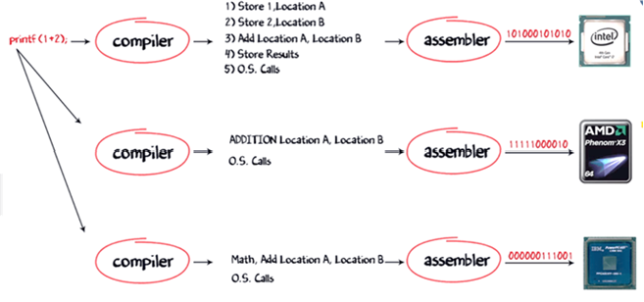



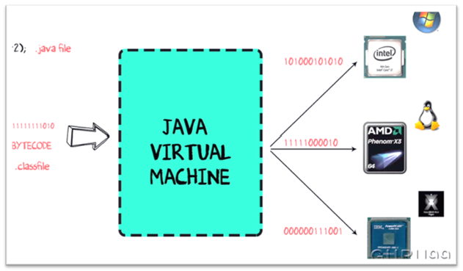

In order to write and execute a software program you need the following

**1) Editor**– To type your program into, a notepad could be used for this

**2) Compiler**– To convert your high language program into native machine code

**3) Linker**– To combine different program files reference in your main program together.

**4) Loader**– To load the files from your secondary storage device like Hard Disk, Flash Drive , CD into RAM for execution. The loading is automatically done when your execute your code.

**5) Execution** – Actual execution of the code which is handled by your OS & processor

How c program execution works:

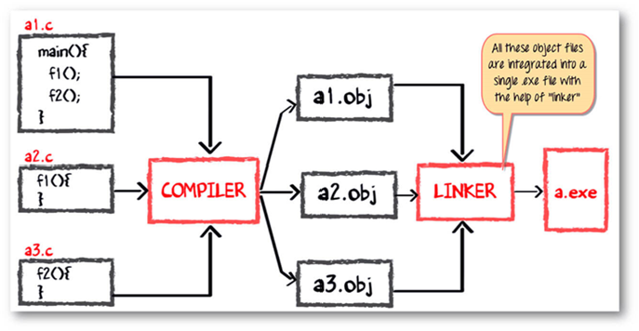

How java program execution works:

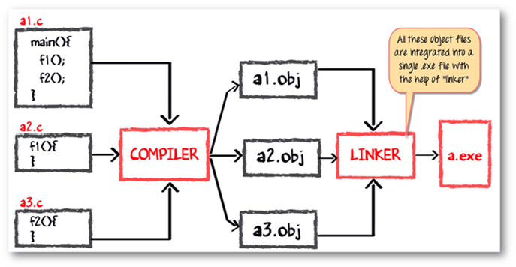

The compiler will compile the three files and produces a corresponding .class file which consists of BYTE code. **Unlike C, no linking is done**.

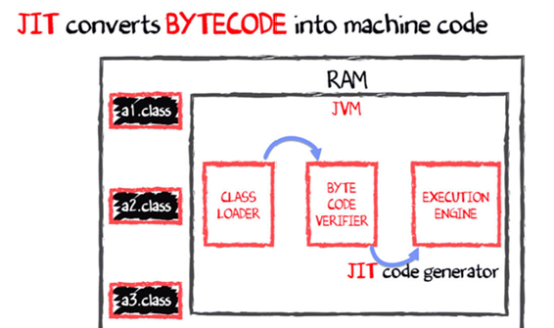The Java VM or Java Virtual Machine resides on the RAM. During execution, using the class loader the class files are brought on the RAM. The BYTE code is verified for any security breaches.

The .class

Will be bought on to jvm using class loader

class loader

using class loader

**JIT - java-in-time compiler**

**JVM - java virtual machine**



JVM: it is responsible for allocating memory space

* Programming languages are classifies as
* Higher Level Language Ex. C++ , Java
* Middle Level Languages Ex. C
* Low Level Language Ex Assembly
* finally the lowest level as the Machine Language.

Why JAVA is both interpreted and compiled language?

A **compiler** is a program which converts a program from one level of language to another. Example conversion of C++ program into machine code.

The java compiler is a convert's high level java code into bytecode (which is also a type of machine code).

A **interpreter**is a program which converts a program at one level to another programming language at the same level. Example conversion of Java program into C++

In Java , the Just In Time Code generator converts the bytecode into the native machine code which are at the same programming levels.

Java platform architecture:



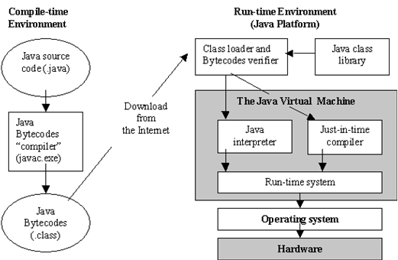 JDK

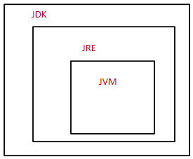

JDK parts has JRE and JVM